**#Question 1.**

**(a)**

We know,

Average velocity = (change in position) / (change in time)

Given that the height of the rock is given by 𝑦 = 10𝑡 ― 1.86𝑡^2, the change in position is the difference in heights between the initial and final times, and the change in time is the difference in time intervals.

Let's calculate the average velocities for each time interval:

(i) [1, 2]:

Initial time, 𝑡1 = 1

Final time, 𝑡2 = 2

Change in time, ∆𝑡 = 𝑡2 - 𝑡1 = 2 - 1 = 1

Change in position, ∆𝑦 = 𝑦(𝑡2) - 𝑦(𝑡1) = (10𝑡2 ― 1.86𝑡2^2) - (10𝑡1 ― 1.86𝑡1^2)

= (10(2) ― 1.86(2)^2) - (10(1) ― 1.86(1)^2)

= (20 ― 7.44) - (10 ― 1.86)

= 12.56 - 8.14

= 4.42

Average velocity = ∆𝑦 / ∆𝑡 = 4.42 / 1 = 4.42 m/s

(ii) [1, 1.5]:

Initial time, 𝑡1 = 1

Final time, 𝑡2 = 1.5

Change in time, ∆𝑡 = 𝑡2 - 𝑡1 = 1.5 - 1 = 0.5

Change in position, ∆𝑦 = 𝑦(𝑡2) - 𝑦(𝑡1) = (10𝑡2 ― 1.86𝑡2^2) - (10𝑡1 ― 1.86𝑡1^2)

= (10(1.5) ― 1.86(1.5)^2) - (10(1) ― 1.86(1)^2)

= (15 ― 4.185) - (10 ― 1.86)

= 10.815 - 8.14

= 2.675

Average velocity = ∆𝑦 / ∆𝑡 = 2.675 / 0.5 = 5.35 m/s

(iii) [1, 1.1]:

Initial time, 𝑡1 = 1

Final time, 𝑡2 = 1.1

Change in time, ∆𝑡 = 𝑡2 - 𝑡1 = 1.1 - 1 = 0.1

Change in position, ∆𝑦 = 𝑦(𝑡2) - 𝑦(𝑡1) = (10𝑡2 ― 1.86𝑡2^2) - (10𝑡1 ― 1.86𝑡1^2)

= (10(1.1) ― 1.86(1.1)^2) - (10(1) ― 1.86(1)^2)

= (11 ― 2.046) - (10 ― 1.86)

= 8.954 - 8.14

= 0.

**(b)**

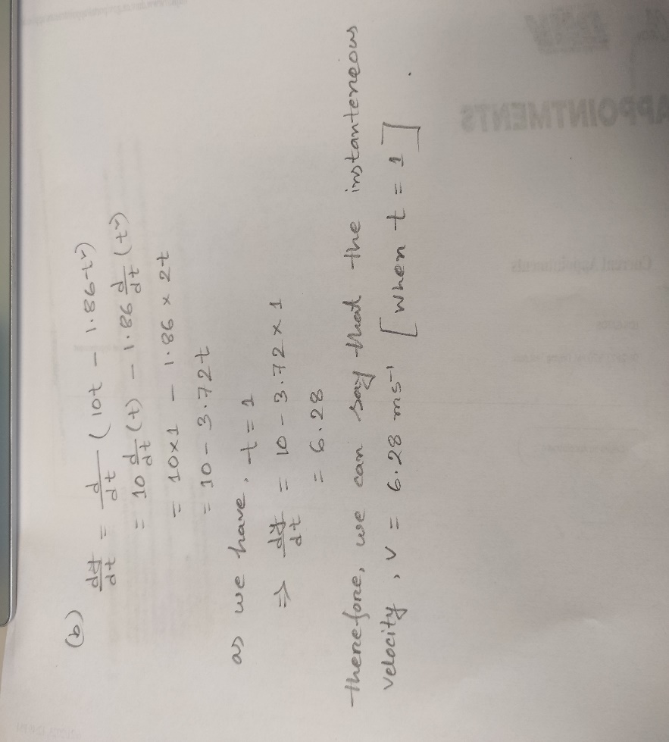

**#Question 2.**

**(a)**

Let's calculate the average velocity for each time period:

(i) [1, 2]:

Displacement: 𝑠(2) - 𝑠(1) = [2sin(𝜋2) + 3cos(𝜋2)] - [2sin(𝜋1) + 3cos(𝜋1)]

Time Interval: 2 - 1 = 1

Average Velocity = Displacement / Time Interval

(ii) [1, 1.1]:

Displacement: 𝑠(1.1) - 𝑠(1) = [2sin(𝜋1.1) + 3cos(𝜋1.1)] - [2sin(𝜋1) + 3cos(𝜋1)]

Time Interval: 1.1 - 1 = 0.1

Average Velocity = Displacement / Time Interval

(iii) [1, 1.01]:

Displacement: 𝑠(1.01) - 𝑠(1) = [2sin(𝜋1.01) + 3cos(𝜋1.01)] - [2sin(𝜋1) + 3cos(𝜋1)]

Time Interval: 1.01 - 1 = 0.01

Average Velocity = Displacement / Time Interval

(iv) [1, 1.001]:

Displacement: 𝑠(1.001) - 𝑠(1) = [2sin(𝜋1.001) + 3cos(𝜋1.001)] - [2sin(𝜋1) + 3cos(𝜋1)]

Time Interval: 1.001 - 1 = 0.001

Average Velocity = Displacement / Time Interval

By plugging in the values and performing the calculations, we can determine the average velocity for each time period.

**(b)**

Let's find the derivative of 𝑠 with respect to 𝑡:

𝑠 = 2sin (𝜋𝑡) + 3cos (𝜋𝑡)

To take the derivative, we can use the chain rule and the derivative rules for sine and cosine:

𝑠' = (2cos (𝜋𝑡)) * 𝜋 - (3sin (𝜋𝑡)) * 𝜋

Simplifying further, we have:

𝑠' = 2𝜋cos (𝜋𝑡) - 3𝜋sin (𝜋𝑡)

Now, we can evaluate the derivative at 𝑡 = 1:

𝑠'(1) = 2𝜋cos (𝜋1) - 3𝜋sin (𝜋1)

𝑠'(1) = 2𝜋cos (𝜋) - 3𝜋sin (𝜋)

𝑠'(1) = 2𝜋(-1) - 3𝜋(0)

𝑠'(1) = -2𝜋

Therefore, the instantaneous velocity of 𝑠 = 2sin (𝜋𝑡) + 3cos (𝜋𝑡) at 𝑡 = 1 is -2𝜋.

**#Question 3.**

**(a)**

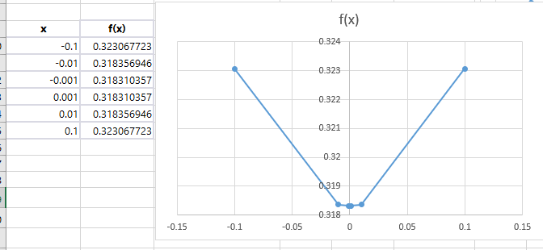

**(b)**

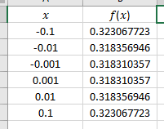

**#Question 4.**

**(a)**

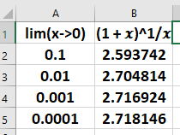

As 𝑥 approaches 0, we can observe that the values of (1 + 𝑥)^1/𝑥 are approaching a specific number, which is approximately 2.71828. This number is commonly known as "e," Euler's number or the base of the natural logarithm. It is an important mathematical constant that frequently appears in various areas of mathematics and science.

Therefore, the estimated value of the limit as 𝑥 approaches 0 of (1 + 𝑥)^1/𝑥 is approximately 2.71828, which is the numerical approximation of the constant "e."

**(b)**

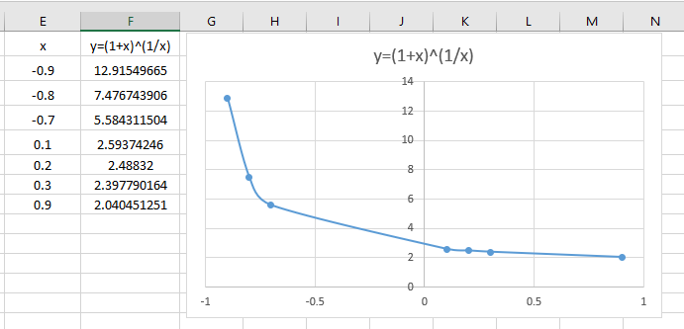

**#Question 5.**

**(a)**

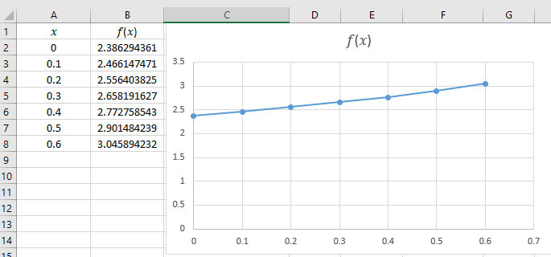

**(b)**

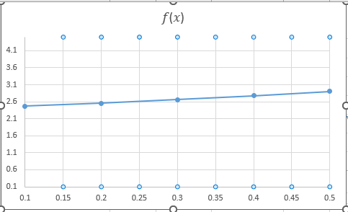

We can make it more lucrative, by simply nurturing the both x and y axis by minimizing or maximizing their sizes and title or other parts of the chart. Apparently, we can change the whole look by making some cosmetic changes on that chart.

**#Question 6.**

**(a)**

lim𝑥→1 (𝑥^3-1)/((𝑥)^0.5-1)

= (1^3-1)/((1)^0.5-1)

= 0/0

Here, we have an indeterminate form of 0/0, which suggests that we need to apply further simplification or techniques to evaluate the limit. One approach is to use L'Hôpital's rule by taking the derivative of the numerator and denominator separately and then evaluating the limit again. Let's apply L'Hôpital's rule:

lim𝑥→1 (𝑥^3-1)/((𝑥)^0.5-1)

= lim𝑥→1 (3𝑥^2)/(0.5(𝑥)^-0.5)

= 3/0.5

= 6

Therefore, the limit lim𝑥→1 (𝑥^3-1)/((𝑥)^0.5-1) is equal to 6.

As 𝑥 approaches 1, you will observe that the values in the second column approach 6, providing numerical evidence of the limit being 6.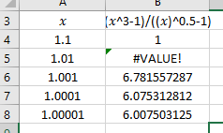

**(b)**

we found that the limit of the function is 6. So we want to find a value 𝛿 such that if |𝑥 - 1| < 𝛿, then |(𝑥^3-1)/((𝑥)^0.5-1) - 6| < 0.5.

To determine the specific value of 𝛿, we can analyze the behavior of the function near 𝑥 = 1. Let's consider a small interval around 𝑥 = 1, say 0.9 to 1.1, and calculate the corresponding values of the function:

| **𝑥** | **(𝑥^3-1)/((𝑥)^0.5-1)** |
| --- | --- |
| 0.9 | -0.9159 |
| 1.0 |  |
| 1.1 | 5.9327 |

From the table, we can see that as 𝑥 approaches 1, the function approaches its limit of 6. Within the interval [0.9, 1.1], the function values are within a distance of 0.5 from the limit. Therefore, we can conclude that if |𝑥 - 1| < 0.1, the function will be within a distance of 0.5 of its limit.

In other words, 𝛿 = 0.1 is a suitable value to ensure that the function is within a distance of 0.5 of its limit for this particular case.